CS543 Assignment 4

**Your Name:** Hongbo Zheng

**Your NetId:** hongboz2

# Part 1 Single-View Geometry:

​​**Plot the VPs and the lines used to estimate them on the image plane using the provided code.**

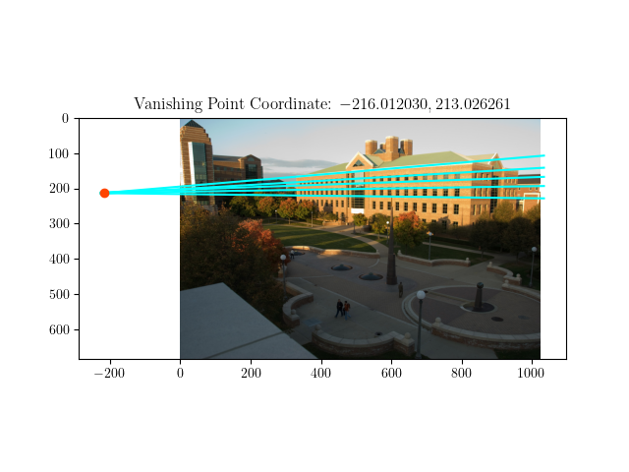

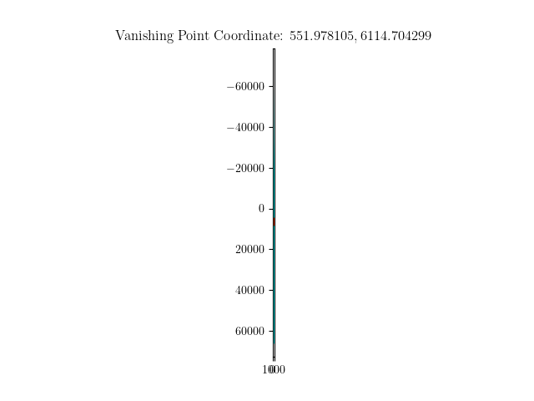

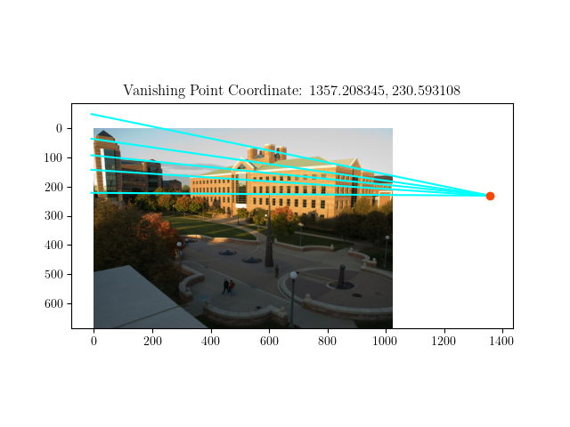

**Specify the VP pixel coordinates.**

The VP pixel coordinates are shown in the title of the 3 images above.

**Plot the ground horizon line and specify its parameters in the form a * x + b * y + c = 0. Normalize the parameters so that: a^2 + b^2 = 1.**

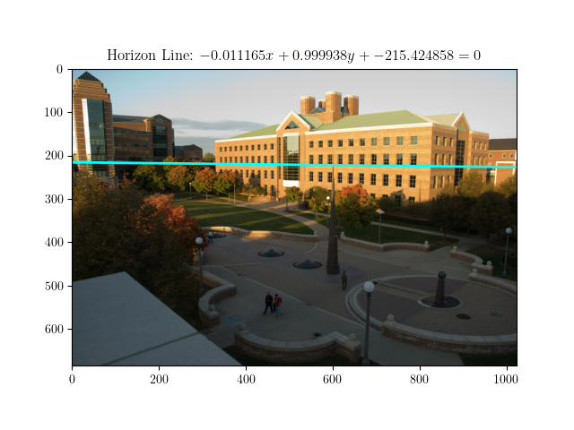

**Using the interface, construct the lines on the image that establish that the two gables on the CSL building are the same height. Explain why these lines do so.**

The two yellow lines in the two images below are the lines used to measure whether the two gables on the CSL building are the same height. The coordinates of the first gable are [508.03245865, 96.14044411, 1] and [507.06589659, 138.66917432, 1]. The coordinates of the second gable are [900.9455353, 101.1373913, 1] and [899.03062179, 143.26548855, 1].

Treat the first gable as reference, and the second gable as object. The line_ref_obj is first calculated by numpy.cross reference bottom and object bottom, and then numpy.cross with horizon_line to get v. The line_v_ref_t is calculated by numpy.cross v and reference top. Additionally, line_r_b is calculated by numpy.cross object top and object bottom. Finally, t is calculated with numpy.cross line_v_ref_t and line_r_b. Use the camera cross ratio formula in Professor Hoiem’s book to calculate the ratio to be 0.993542.

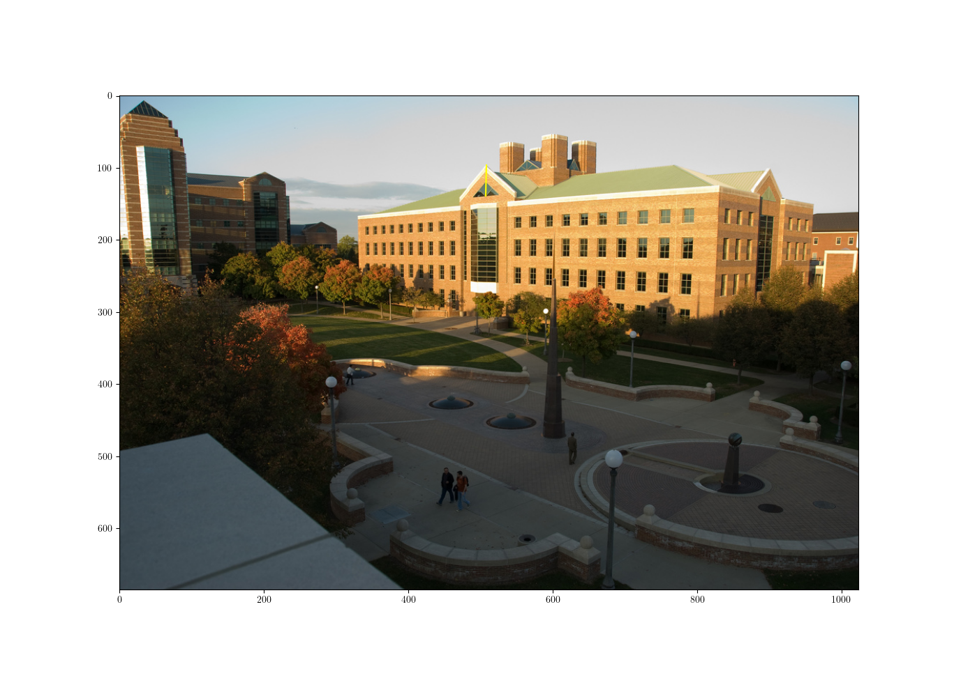

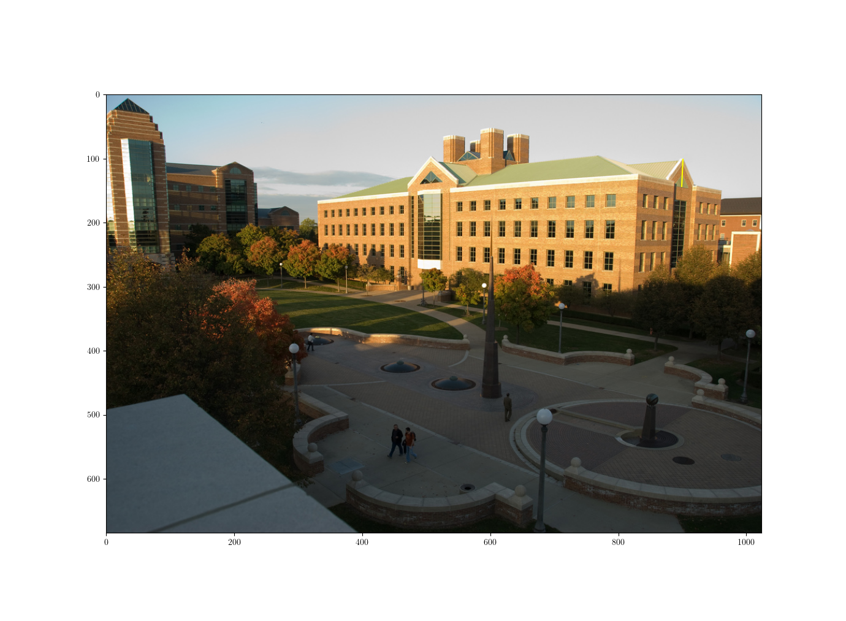

# Part 2 Fundamental Matrix Estimation, Camera Calibration, Triangulation:

## **For the lab and library image pairs, display your result (points and epipolar lines) and report your residual for both unnormalized and normalized fundamental matrix estimation.**

The residuals for both non-normalized and normalized fundamental matrix estimation are shown on the image.

Lab:

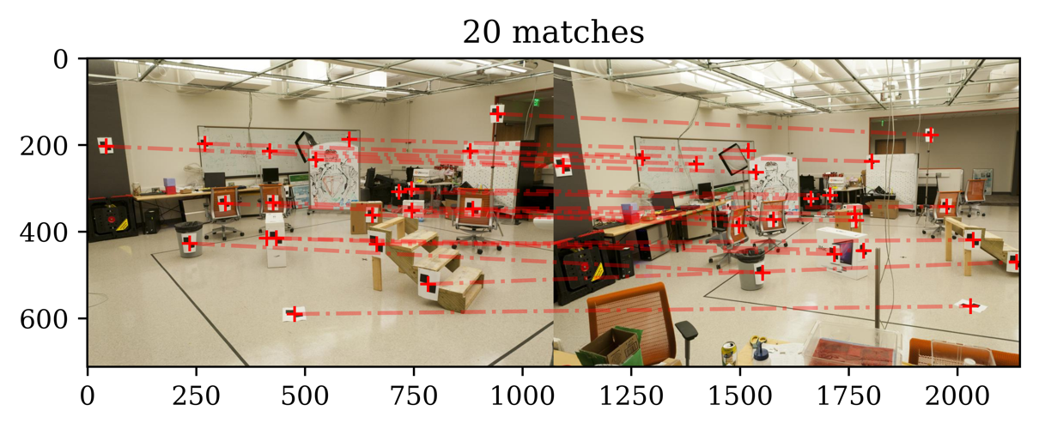

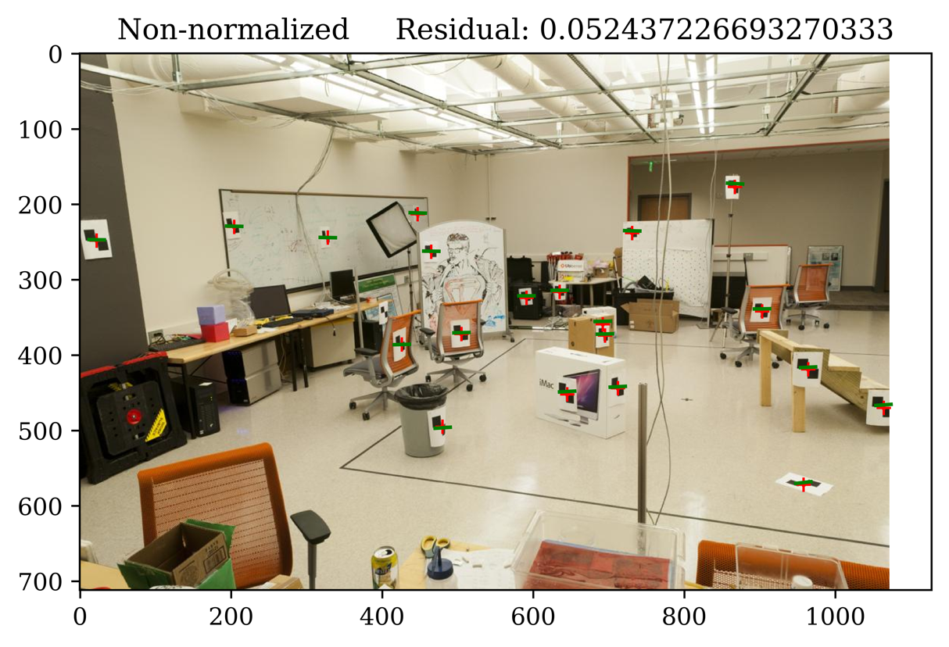

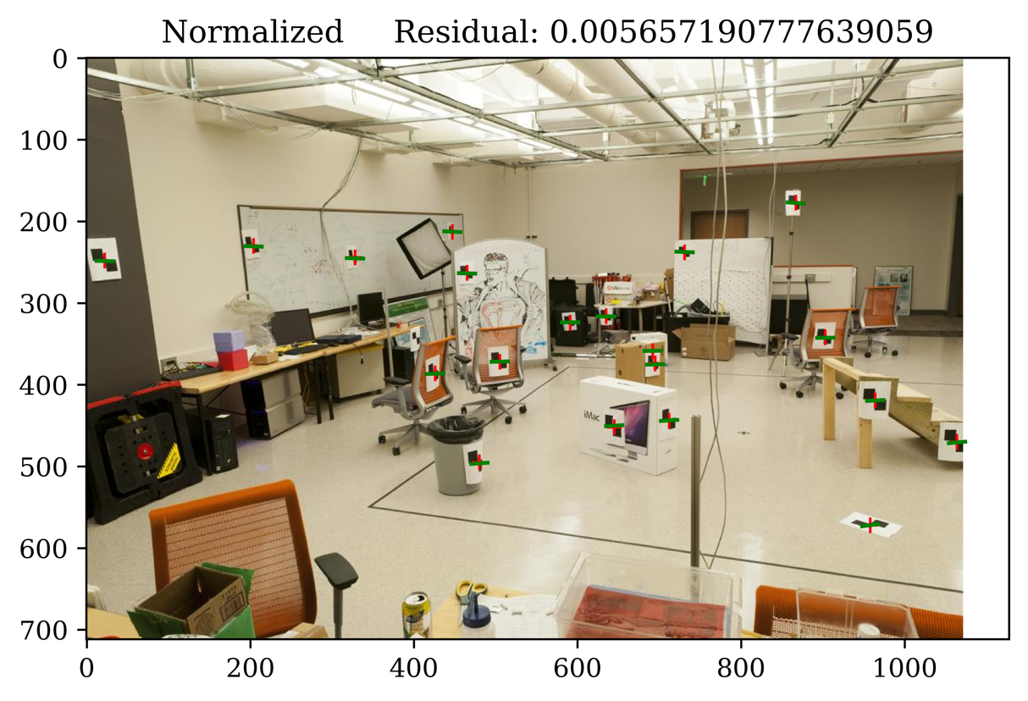

Library:

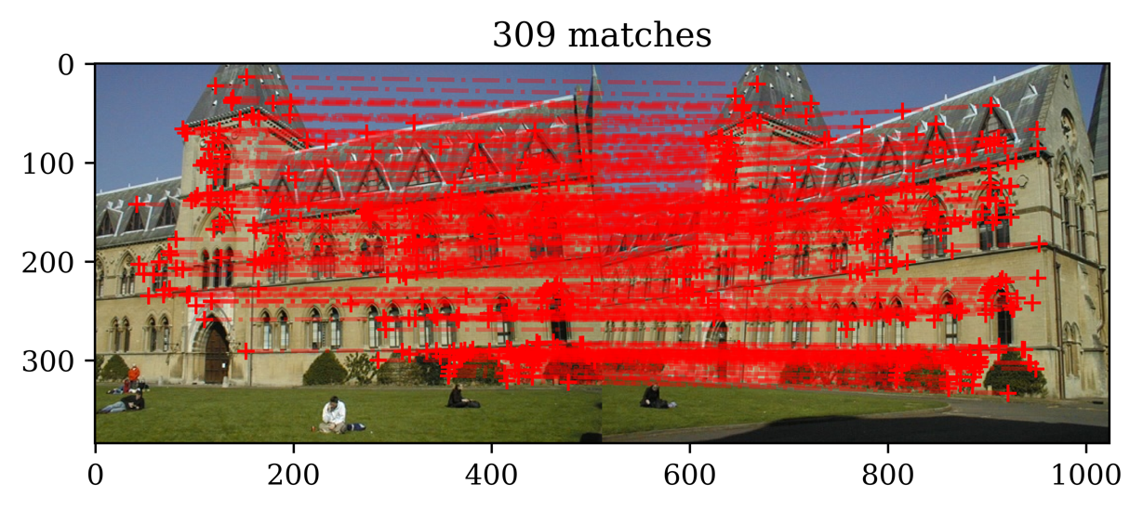

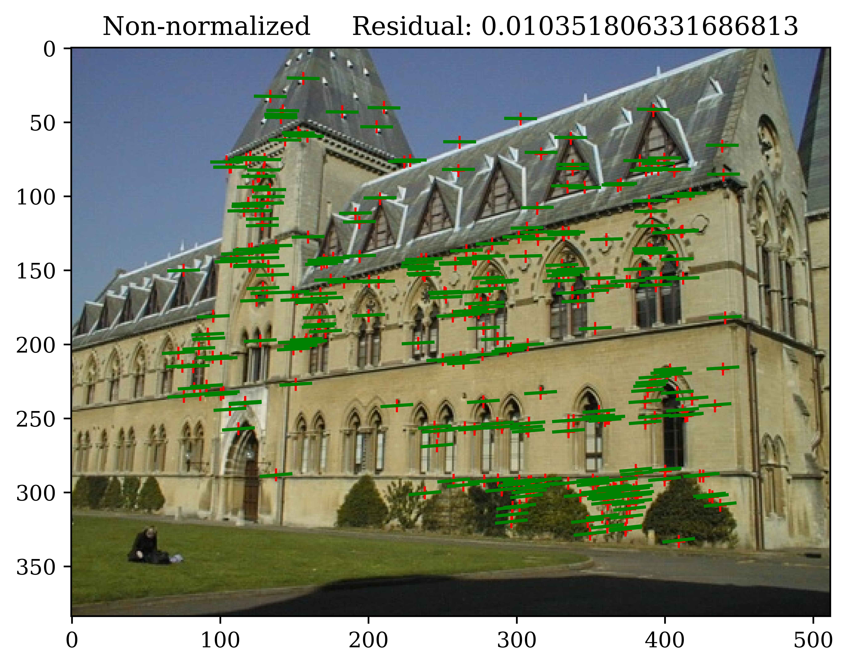

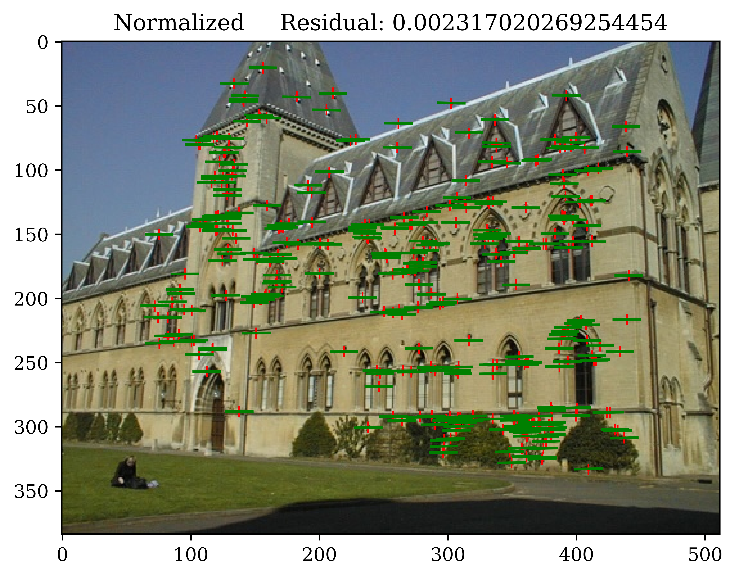

## **For the lab image pair, show your estimated 3x4 camera projection matrices. Report the residual between the projected and observed 2D points.**

Lab 1 Image:

Lab 1 Camera Projection Matrix

[[ 3.09963996e-03 1.46204548e-04 -4.48497465e-04 -9.78930678e-01]

[ 3.07018252e-04 6.37193664e-04 -2.77356178e-03 -2.04144405e-01]

[ 1.67933533e-06 2.74767684e-06 -6.83964827e-07 -1.32882928e-03]]

Lab 1 2D -> Projected 2D Residual: 13.545833

Lab 2 Image:

Lab 2 Camera Projection Matrix

[[ 6.93154686e-03 -4.01684470e-03 -1.32602928e-03 -8.26700554e-01]

[ 1.54768732e-03 1.02452760e-03 -7.27440714e-03 -5.62523256e-01]

[ 7.60946050e-06 3.70953989e-06 -1.90203244e-06 -3.38807712e-03]]

Lab 2 2D -> Projected 2D Residual: 15.544953

## **For the lab and library image pairs, visualize 3D camera centers and triangulated 3D points.**

Lab 2D -> Triangulated 3D Average Residual: 0.168330; Total Residual: 13.466388

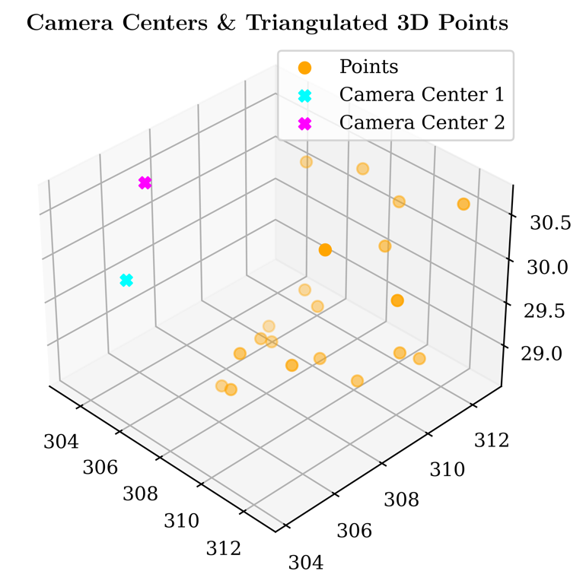

Library 2D -> Triangulated 3D Average Residual: 0.044422; Total Residual: 54.905466

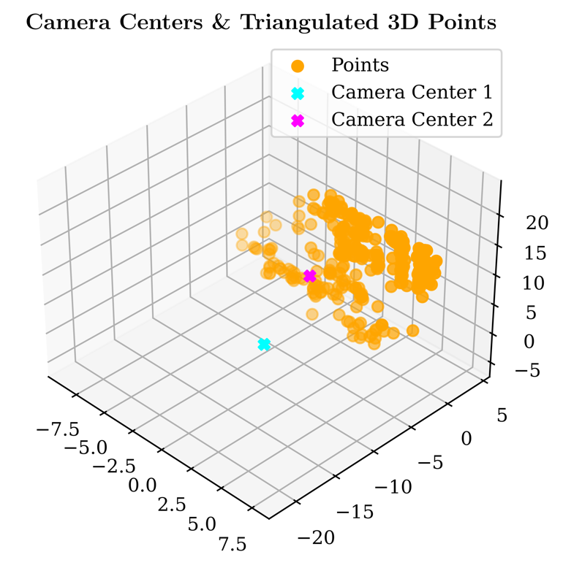

The 2D -> Triangulated 3D Residual is calculated by transforming the Triangulated 3D points back to 2 sets of 2D points (one set for each image) with M_1 and M_2 and then sum up the total loss between the two sets of 2D transformed points with the original two sets of 2D points.

## **For the house and gaudi image pairs, display your result and report your number of inliers and average inlier residual for normalized estimation without ground truth matches.**

RANSAC # of Inliner Matches & RANSAC Average Residual are shown on the RANSAC image, Residual of fundamental matrix estimation is shown on the second image.

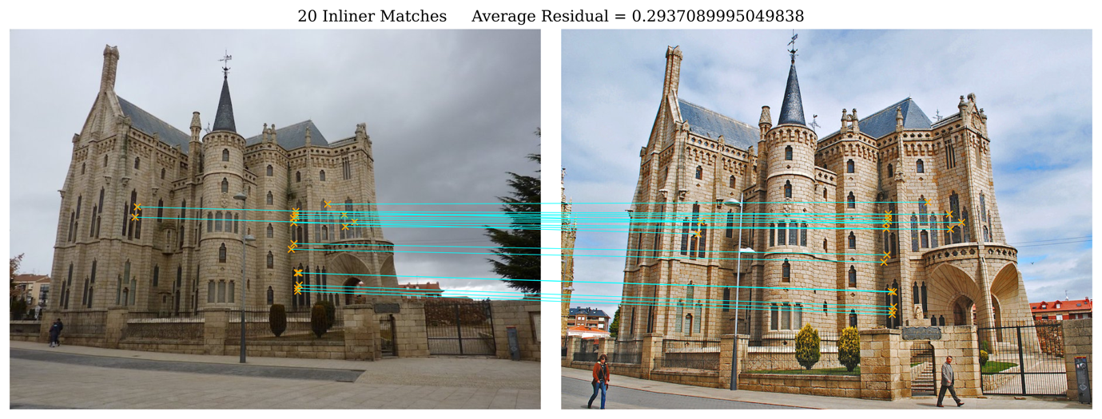

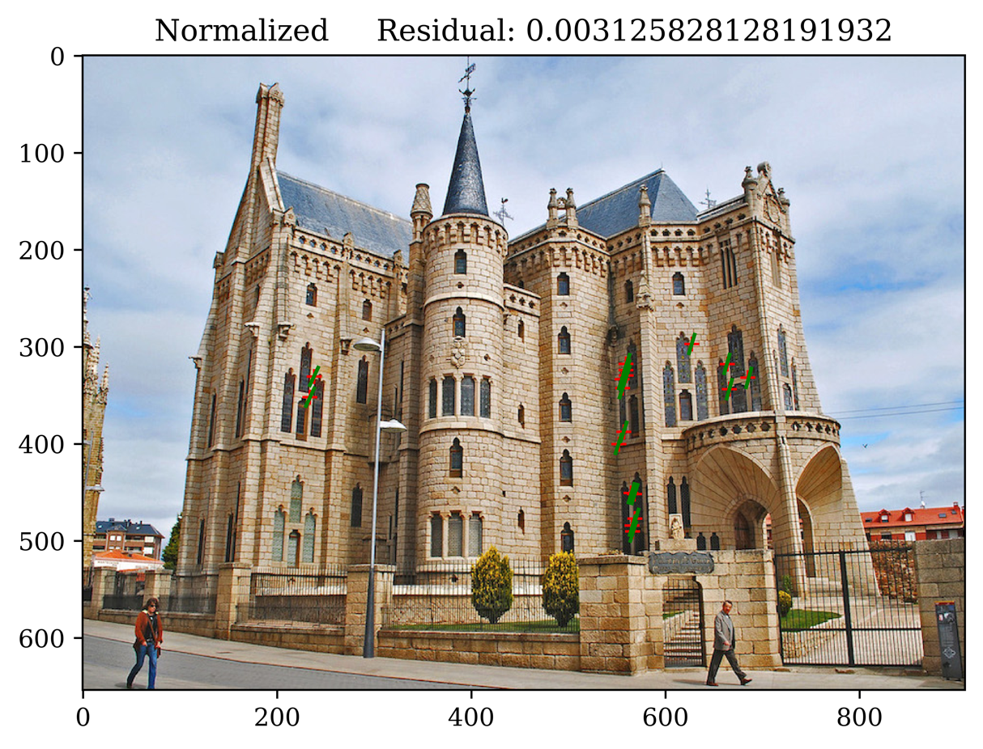

House:

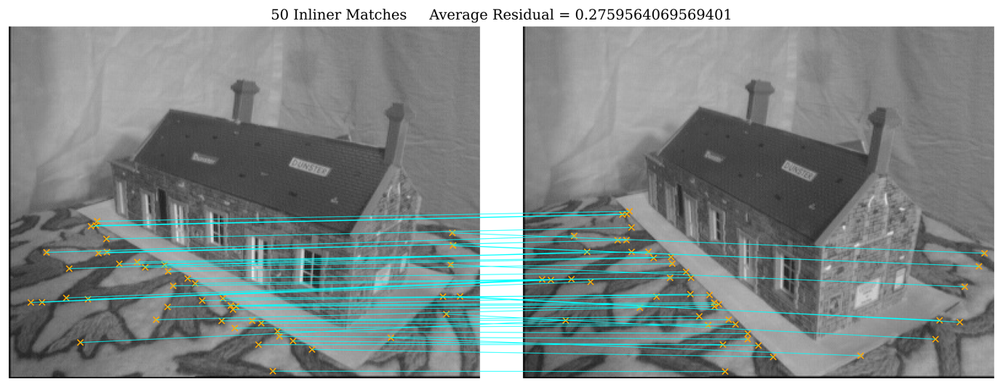

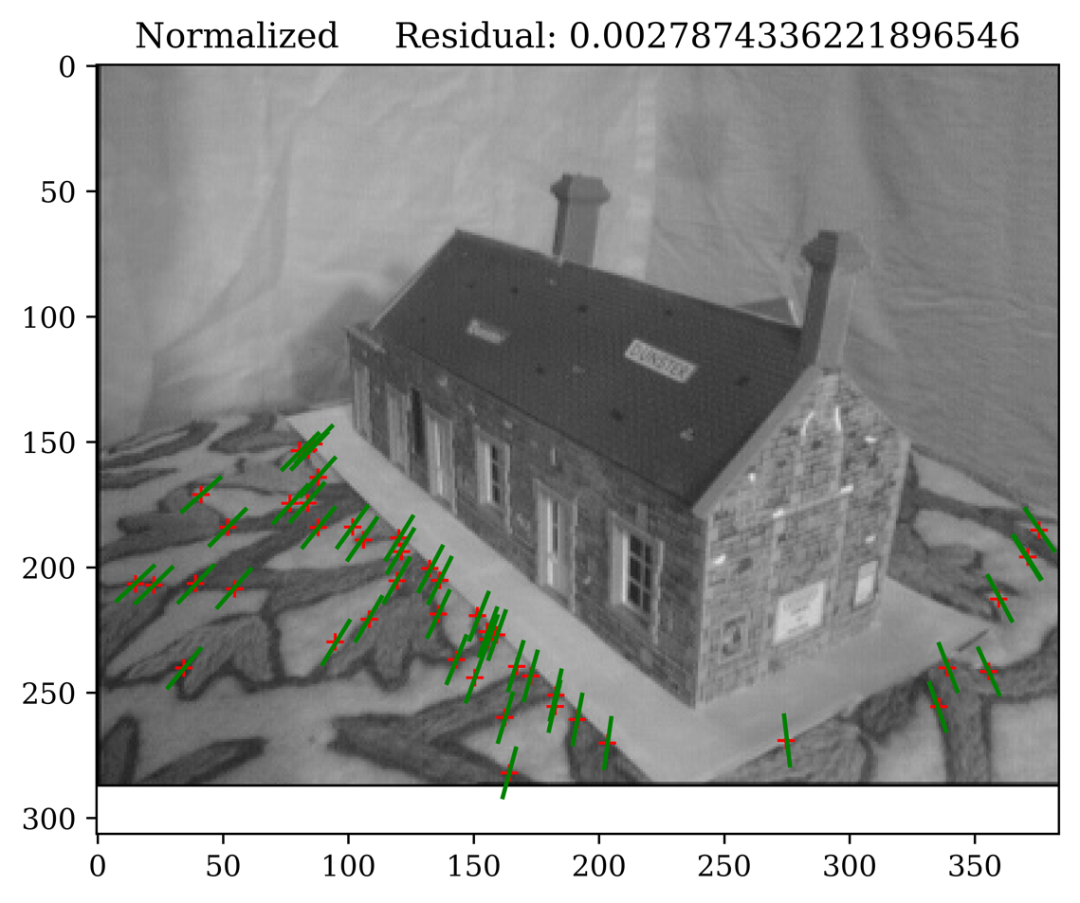

# Extra Credit:

Don’t forget to include references, an explanation, and outputs to receive credit.